Project Management System
Software Requirements Specification

Version 1.0



Group Id: FYP-09-02
Supervisor Name : Sir Tehseen qureshi

Revision History
Date (dd/mm/yyyy) | Version | Description | Author
2/23/2019 | 1.0 | PMS project focus on scope, functional and non-functional requirement, and use case diagram, Usage Scenarios, adopted methodology and work plan.  This project requires developing an online digitizes a lot of processes which involve student final year project result processing. These processes range from students’ registration, discussions, assigning supervisors, assigning tasks, producing of students result reports and result notification as well…… | 1474

Table of Contents

- Scope (of the project)
- Functional Requirements Non Functional requirements
- Use Case Diagram
- Usage Scenarios
- Adopted Methodology
- Work Plan (Use MS Project to create Schedule/Work Plan)

SRS Document

Scope of Project:

Learning management system is a web based application. This application has wide scope in educational institutions. Any institute having students of final year can use this project for management of the final year projects.
This project requires developing an online digitizes a lot of processes which involve student final year project result processing. These processes range from students’ registration, discussions, assigning supervisors, assigning tasks, producing of students result reports and result notification as well……

Functional and non-Functional Requirements:

Functional Requirements:
- Admin have full access of the system.
- Admin announces the final result.
- Admin assign supervisors to groups.
- Admin post notification on notification page.
- Admin can update profile and password.
- Teacher login or signup to the system.
- Teacher can update profile and password.
- Teacher can create and view tasks.
- Teacher can manage groups and discussions.
- Teacher submits result to the admin.
- Student can login or signup to the system.
- Student can update profile and password.
- Student can view task.
- Student can discuss problems with teacher and fellows in discussion
Non-Functional Requirements:
A requirement that specifies criteria that can be used to judge the operations of a system, rather than specific behaviors. “A non-functional requirement is a statement of how a system must behave; it is a constraint upon the systems behavior.
- User Friendly GUI
User Interface should to be easy to use i.e. simple to learn, simple to recall and simple to utilize. All controls on structures must to act naturally illustrative.

- Performance
Web Application should to be planned and created such that it should not use excessively numerous assets of the computer consequently influencing it to moderate.
- Reusability
Application should be designed and developed in such a way that its modules can be ported and integrated to other applications with minor changes.

- Responsiveness
This system is fully responsive.
- Availability
System is always available.
- Security
System is fully secure.
- Recoverability
Facility to recover data in case of any crash.

Project Domain:
Web Programming

Tools:
- Server side language: NodeJS
- Scripting and styling Language: HTML5, CSS3
- Client side scripting: JavaScript and Material UI
- Database: Mongo DB
- IDE: Visual Studio code
- Local Host Server: HTTP

Use Case Diagram(s):

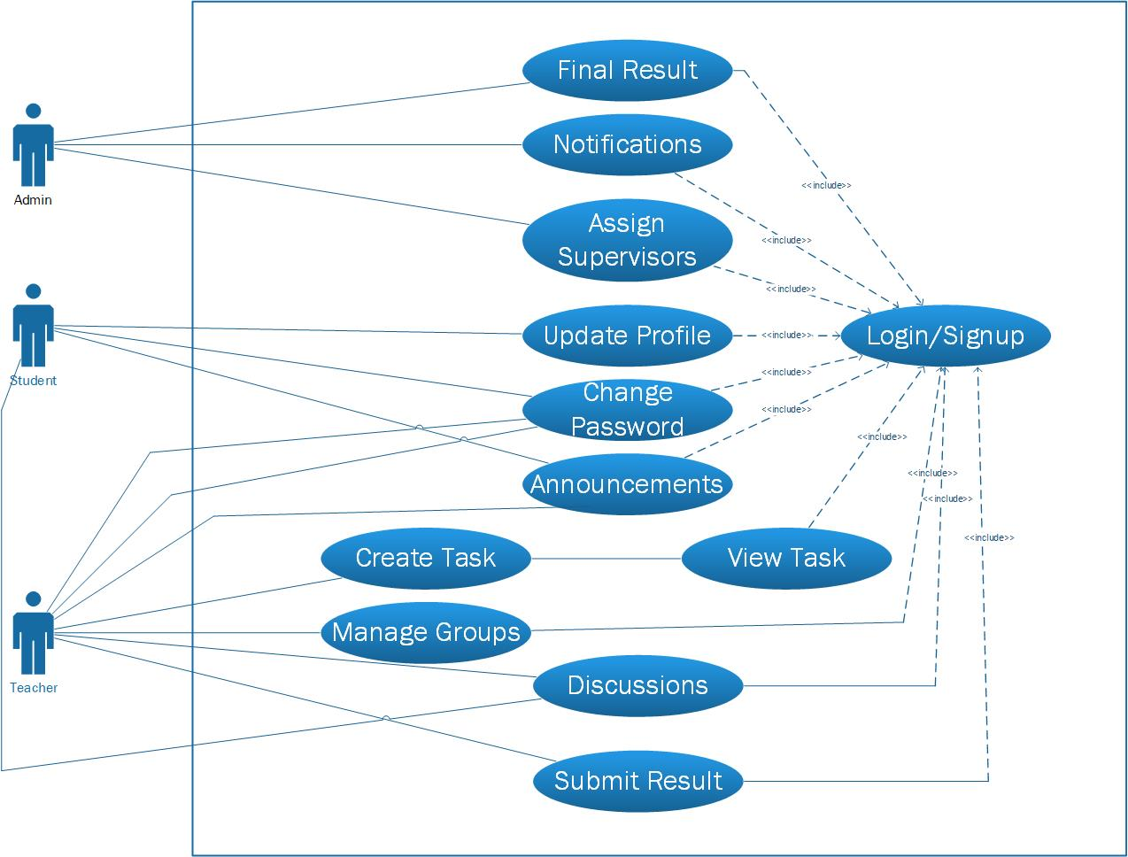

Usage Scenarios:

Use Case Title: | Final Result
Use Case Id | PMS_FR_1
Actors | Admin, Student
Actions | - Admin post the final result of projects.  - Students view their result.
Description | The admin post the final result on portal submitted by the groups supervisors and students can check their result.
Alternative Paths | In case of any mistake contact to admin or teacher to correct.
Pre-Conditions | The admin or student must be logged into the system.
Post Conditions | Student can see the result
Author | 1474
Exceptions | Teacher submit result of student again but they cannot update in database.

Use Case Title: | Notification
Use Case Id | PMS_FR_2
Actors | Admin, Student, Teacher
Actions | - Admin post notification regarding FYP on portal.  - Teachers and students can view the notification
Description | The admin post notification on the portal regarding FYP activities and students and teacher view the notifications.
Alternative Paths
Pre-Conditions | The admin, student and teacher must be logged into the system.
Post Conditions | Students and teachers can view the notifications.
Author | 1474
Exceptions

Use Case Title: | Assign Supervisors
Use Case Id | PMS_FR_3
Actors | Admin
Actions | - Admin assign available supervisors to student groups.
Description | The admin checks the available supervisors and assign them to the groups of students.
Alternative Paths | In case of supervisor is not available then more groups assigned to existing supervisors
Pre-Conditions | There are groups needs to assign supervisors.
Post Conditions | Supervisors assigned to the groups.
Author | 1474
Exceptions | There is no any supervisor is available

Use Case Title: | Update Profile
Use Case Id | PMS_FR_4
Actors | Admin, Teacher, Student
Actions | - Actor login and go to settings > Profile to update profile  - Actor changes the necessary things and then clicks update.
Description | Actor can change information regarding his profile
Alternative Paths | If there is problem in update in database the contact admin.
Pre-Conditions | Actor must be logged into system.
Post Conditions | Profile updated successfully.
Author | 1474
Exceptions | Actor change his profile successfully and now displays his new updated profile.

Use Case Title: | Change Password
Use Case Id | PMS_FR_5
Actors | Admin, teacher and students
Actions | - Actor login and go to setting their password change  - In password the option old password, new password and confirm password  - Admin have default password
Description | The actor change password
Alternative Paths | In case if teacher and student password forget than contact to admin.
Pre-Conditions | If forget password then Password not change
Post Conditions | The actors can change password
Author | 1474
Exceptions | Actor password change successfully then next time log in with new password

Use Case Title: | Announcements
Use Case Id | PMS_FR_6
Actors | Teacher and students
Actions | - Teacher place any announcement regarding FYP activities.  - Student can view the announcement.
Description | Teacher announces about any FYP activity and student view that announcement.
Alternative Paths | If there is any doubt about announcement then teacher re announces.
Pre-Conditions | Teacher must be logged into the system
Post Conditions | Announcement is successfully placed
Author | 1474
Exceptions | Student view the announcement.

Use Case Title: | Create Task
Use Case Id | PMS_FR_7
Actors | Teacher
Actions | - Teacher create task for students.
Description | Actor create tasks and assigned individually to every person in group.
Alternative Paths | In case student cannot read task then assign again.
Pre-Conditions | Teacher must be logged into the system
Post Conditions | Task is created successfully.
Author | 1474
Exceptions | Task is assigned.

Use Case Title: | View Task
Use Case Id | PMS_FR_8
Actors | Student
Actions | - Students view the tasks.
Description | Students view their tasks assigned by their supervisors.
Alternative Paths | If any student not have any task then contact his supervisor.
Pre-Conditions | Student must be logged into the system.
Post Conditions | Task is views successfully.
Author | 1474
Exceptions | Student view the Task.

Use Case Title: | Manage Groups
Use Case Id | PMS_FR_9
Actors | Teacher
Actions | - Teacher manages groups assigned to him.
Description | Teacher manages each assigned group.
Alternative Paths
Pre-Conditions | Teacher must be logged into the system
Post Conditions | Groups are managed.
Author | 1474
Exceptions

Use Case Title: | Discussion
Use Case Id | PMS_FR_10
Actors | Teacher, Student
Actions | - Actors can communication with each other.
Description | Actors communicate with each other. Students describe their problems to supervisor and supervisor answer them
Alternative Paths
Pre-Conditions | Actor must be logged into the system
Post Conditions | Students and teacher communicate each other.
Author | 1474
Exceptions | Students successfully interact with their teacher.

Use Case Title: | Submit Result
Use Case Id | PMS_FR_11
Actors | Teacher
Actions | - Actor submit result.
Description | Actor submits his groups result into database.
Alternative Paths | In any case of mistake of result contact to admin then admin contact to teacher to submit valid result.
Pre-Conditions | Student marks associated with his ID.
Post Conditions | Teacher have record of submitted result
Author | 1474
Exceptions | Teacher adds result of his student database. And they cannot update record again.

Adopted Methodology:
"The Waterfall" is a sequential model. It is also known as Linear Sequential Life Cycle Model. It is very easy and comprehensive. In this the whole model is flowing steadily downward. It is the complete and accurate model to make the software projects. The entire process of software development is divided into separate process phases. The phases in Waterfall model are: Requirement Specifications phase, Software Design, Implementation and Testing & Maintenance. It works according to phases of its. One phase complete and work accurately then next phase start. If an error generates in the phase it will remove first, then go to the next phase.
Its permits to fill in as departmentalization and administrative control. It must be noticed that diverse association are working with various labels.
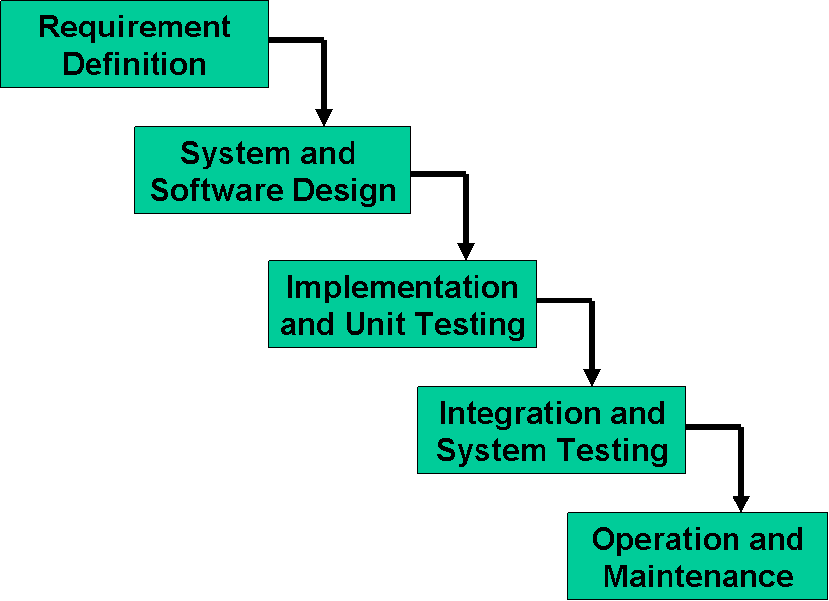
The five stages above are as follows:
- Requirement Analysis and Definition: The systems services, constraints and goals are established by consultation with system users. They are then defined in detail and serve as a system specification.
- System and Software Design: The system design process partitions the requirements to either hardware of software systems. It establishes and overall system architecture. Software design involves fundamental system abstractions and their relationships
- Implementation and Unit Testing: During this stage the software design is realized as a set of programs or program units. Unit testing involves verifying that each unit meets its specifications.
- Integration and system testing: The individual program unit or programs are integrated and tested as a complete system to ensure that the software requirements have been met. After testing, the software system is delivered to the customer.
- Operation and Maintenance: Normally this is the longest phase of the software life cycle. The system is installed and put into practical use. Maintenance involves correcting errors which were not discovered in earlier stages of the life-cycle, improving the implementation of system units and enhancing the system’s services as new requirements are discovered.

Work Plan:

